A.K. SECURITIES

A.K. SECURITIES
Regd. Office: 209 RIVEAIN APTT. TADIWALA ROAD PUNE 411001
Email: aksecurities@vindhyanchaluniversity.in
Phone: 020 26057018, Mob: 9631767280, 9960526521,
Banker: State Bank of India, CSB Bank Oune.

Dt 26.1.22
Sub: : Rough Interna; sheet :” ( Extract of unaudited financial results for the Qr and nine months ended Dec 31, 2021 in Rs.)
Name of Company: A. K. SECURITIES ( A proprietary Company : Proprietor: Archna Khairwar w/o Gopal Khairwar , PAN AFSPK5159D). Registered ( Mumbai Shops and Establishment Act) in short Shop Act .
Business Office:. at Riverain Aptt. 209 , Tadiwala Road Pune-411001,

Business and Investment Activities: As Individual stack holder and Sole Sole Proprietary firm in name and style of A. K. Securities activities related to investments and financial consultation , Trading in Shares and Stocks, MF, Corporate Bond, NCDs , Govt Securities done as per due diligence and investment analysis and charting have been since 1993. We have seen Badla system and and replacing it by Derivative system and off line to on line era, rise and falls in stocks at various time intervals we survived the storms of stock melt down and booms.Now time has come to Incorporate the Proprietary firm into a LLC or a limited Company with great growth prospects commensurate with ease of doing business policy of Government of India and digital exponential growth.

DT: 26.1.22 | SR NO, | EARNING | QUARTER ENDING
1 | 2 | 3 | 4 | 5 | 6 | 7 | 8 | 9
 |  |  | QR 1 | QR 2 | QR3 | QR4 | QR ENDED
 |  |  | QR ENDED  DEC31 ,2021 | QR ENDED DEC 31,2020 | NINE MONTHS ENDED  DEC31,2021

 |  |  | QR ENDED  DEC31 ,2021 | QR ENDED DEC 31,2020 | NINE MONTHS ENDED  DEC31,2021 | CARRIED FOEWAED LOSSESS OF WARE HOUSING SPECIFIED BUIZZ | Od Capital carried forward Loss duly updated at 10% compounded Interest on Initial Capital of Rs. 9.5 Lakh deployed in Specifieed business of A K Securities at 10% cumulative interest on  As per formula: A= P(1+r/n)^(nt)T  Rs. 73 Lakhs Abt
 | 1 | Total income from operations |  |  |  | Link file: mailto:aksecurities@vindhyanchaluniversity.in?subject=CF LOSSES FROM 1999.2000 | As of Capital Loss: 3 Lakh abt  A K SECURITIES_ FINANCE_ QUARTERLY RESULTS.docx
 |  | - ICICIDIRECT.COM  ACC. 8xx..43 | 13040.08 | 486087.20 | 287971.11 | mailto:khairwarg@yahoo.in?subject=STCG FROM ICICIDIRECT TERMINAL TRADING ACC i43
 |  | - KOTAKSECURITIES.COM  Acc. ABC62 |  | << | << | Least activities
 |  | - VENTURA1.COM |  | << | << | Least activities
 |  | - Investment ,FD in Banks
 | 1 | Total income from operations
 | 2 | Net Profit for the period .  ( Before Tax, exceptional and /or extraordinary items)
 | 3 | Net profit for the period before tax. ( after exceptional and /or extraordinary items)
 | 4 | Net profit for the period after tax. (after Exceptional and /or Extraordinary items
 | 5 | Total comprehensive income for the period  ( Comprising Profit for the period (after tax) and Other Comprehensive income (after tax))
 | 6 | Paid up equity Share Capital , Equity share of Rs. 1000/- each
 | 7 | Revenue (excluding revelation reserve)
 | 8 | Earning Per Share (of Rs. 1000/-each )( for continuing and discontinued operations ) ( not annualised for quarters)  - Basic( Rs.)  Dilute ( rs.)
 | 9

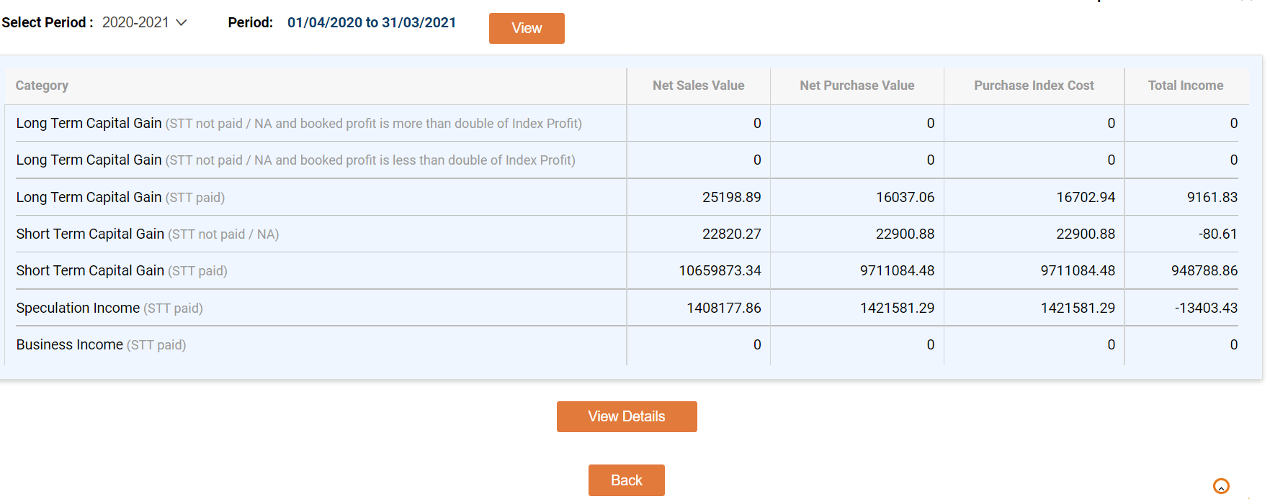

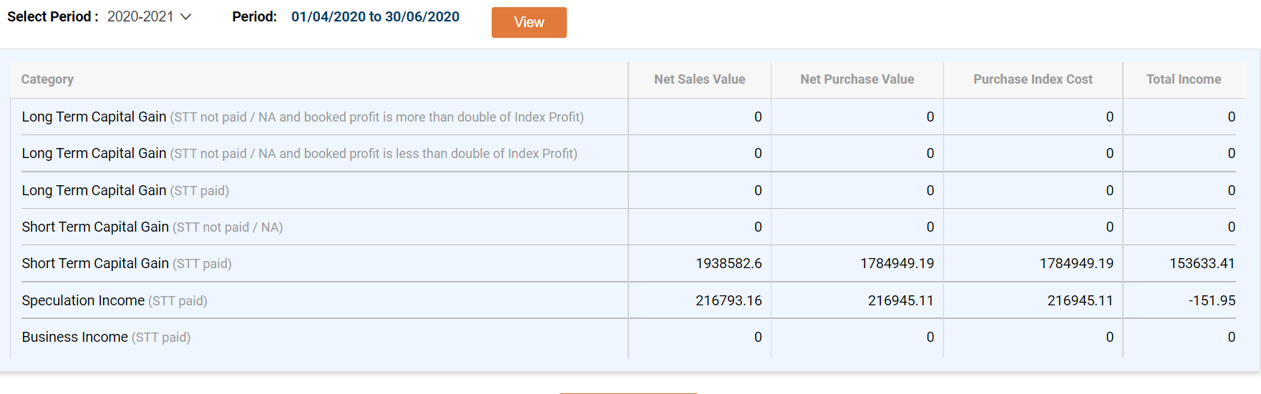 | Q1 FY 2020.21
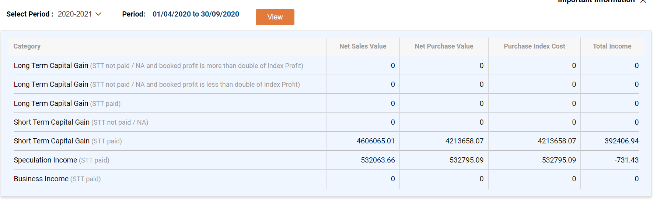 | Q2
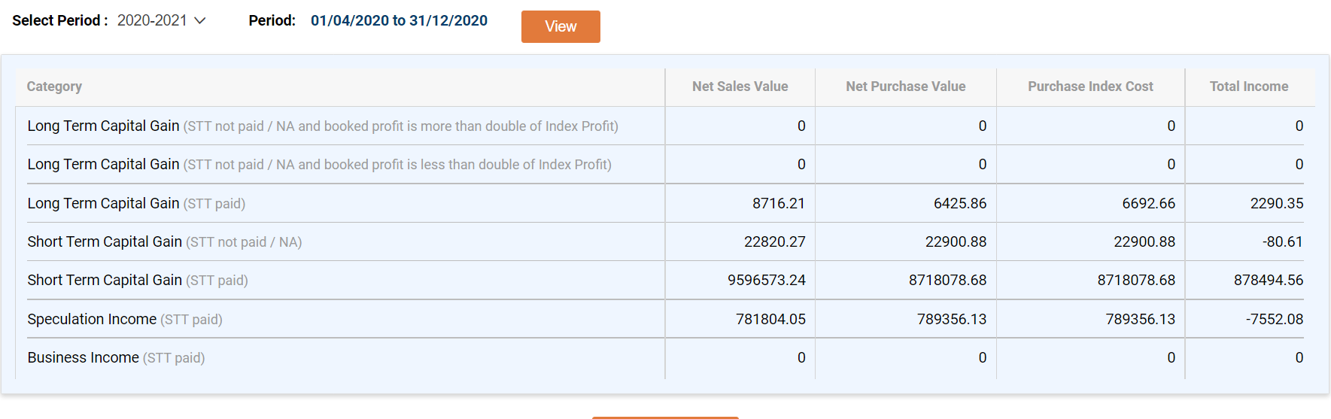 | Q3
 | Q4
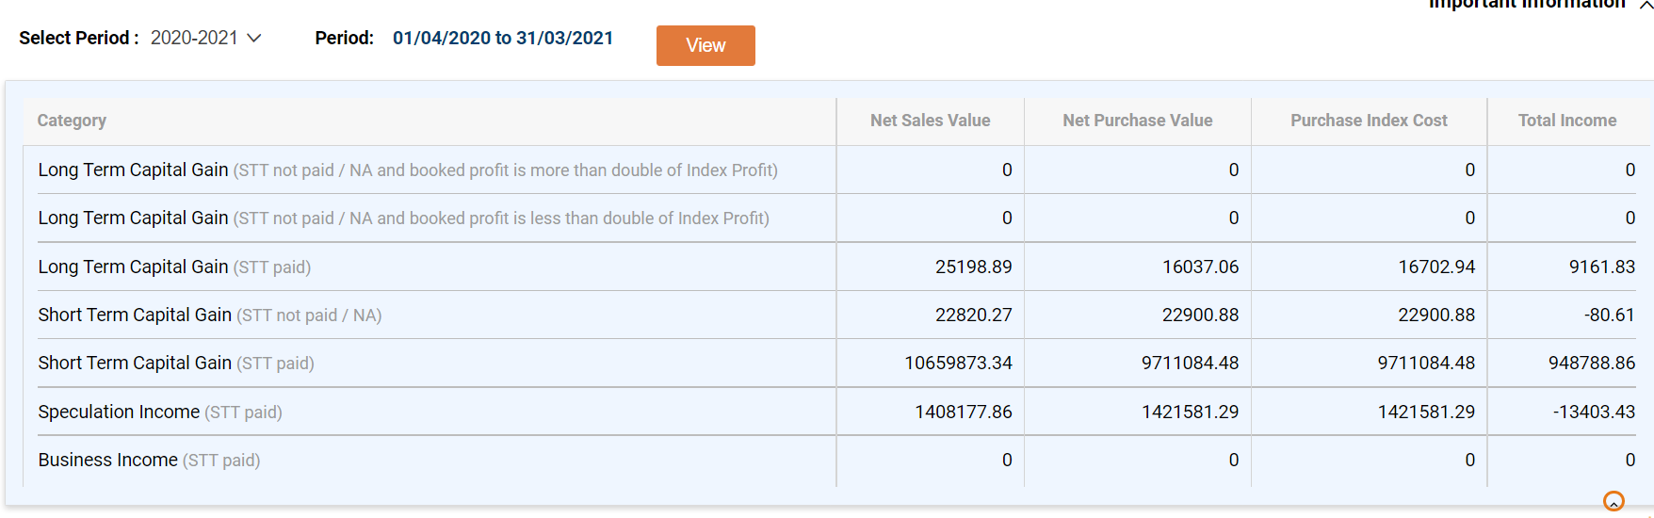 | FY 2020.21  FULL YEAR

 | 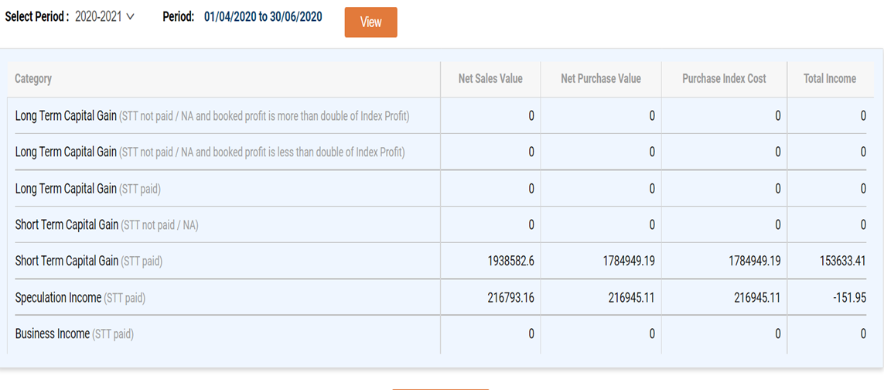 |  |  |  |  | FY 20.21  Q1 RESULT
 | 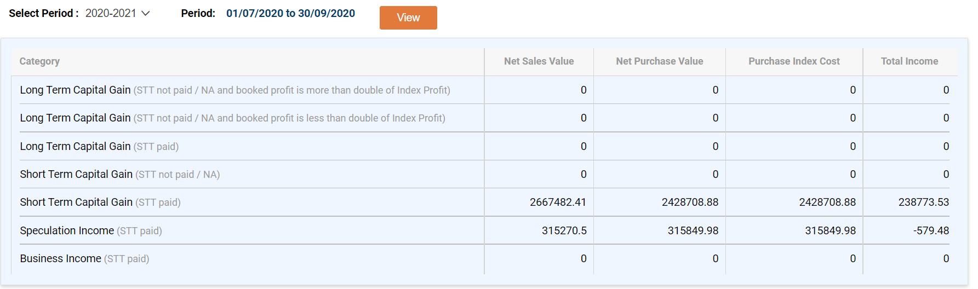 |  |  |  |  | Q2 RESULT
 | 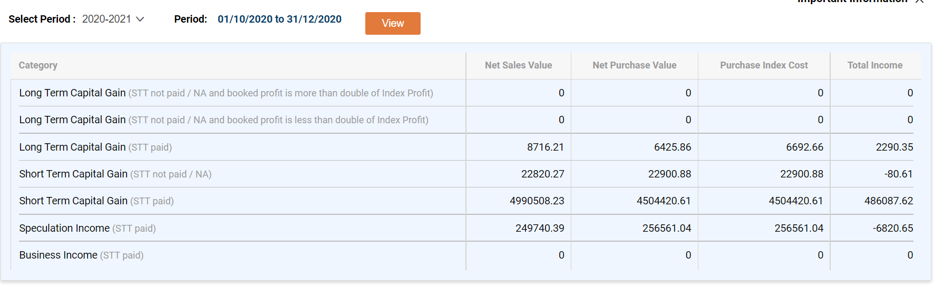 |  |  |  |  | Q3 RESULSTCG: 13040.08
 |  | FY 20.21: Q3 RESULSTCG: 13040.08
 | 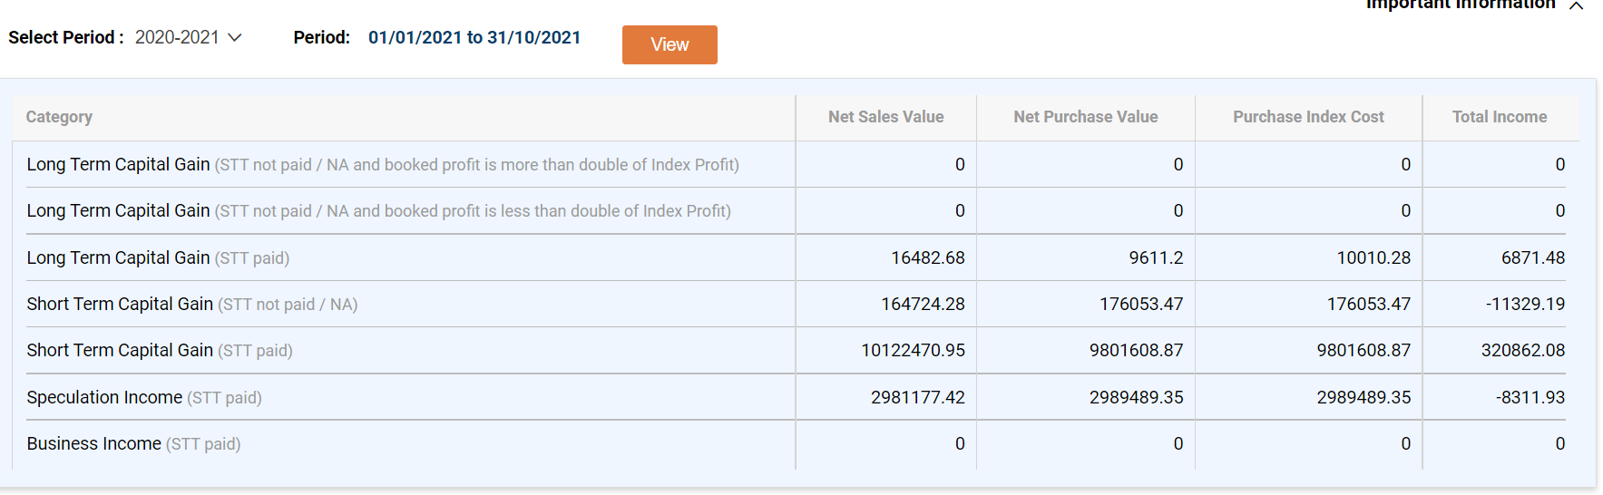 |  |  |  |  | Q4 RESULTS
 | FY 2021.22
I43 |  | 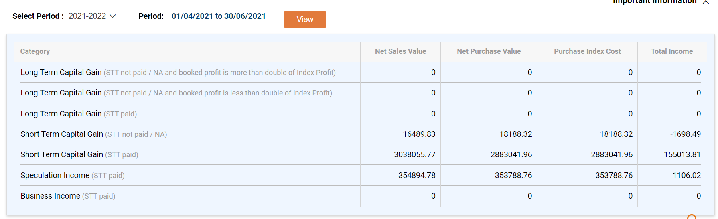  Q1 : FY 2021.22: 155013.81 STCG |  |  |  | I43  Q1 results
 |  | 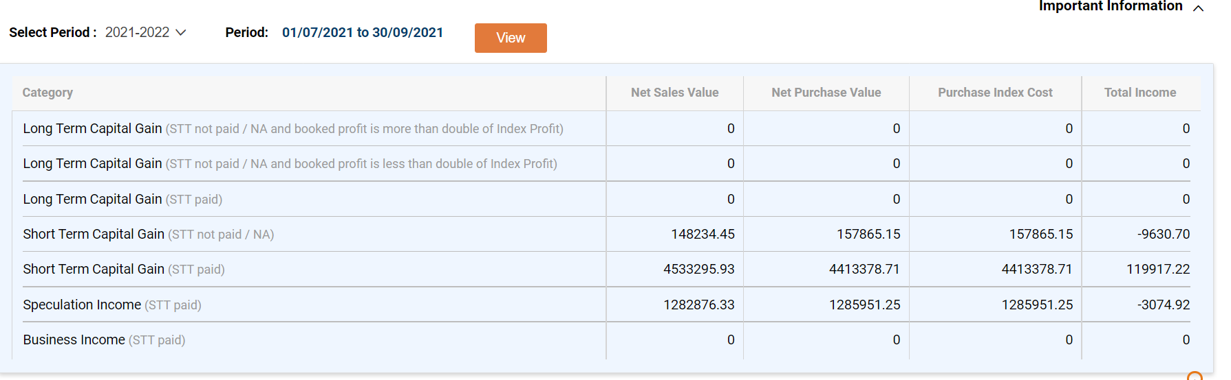  Q2 : FY 2021.22: 119917.22 STCG |  |  |  | Q2 results
 |  | 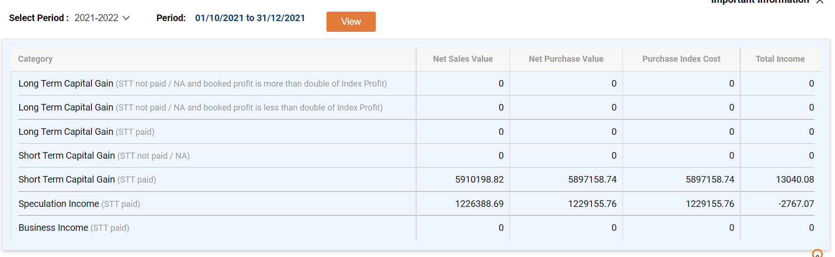  Q3 FY 2021.22: RESULTS: 13040.08 |  |  |  | Q3 results
 |  | 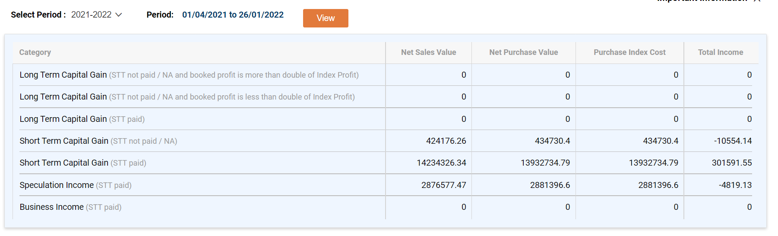 |  |  |  | Cumulative up to q3
 |  | FY 2021.22: From 1.4.21 to As of Cumulative : 26.1.22: 301591.55 |  |  |  | FY 21.22 As of 26.1.22
 |  | 